WELCOME TO GAD 331 CAMERA AND LIGHTING TECHNIQUES!!
Week 2 Readings and Assignments
Complete the following reading early in the week:
- Week 2 online lectures
- Visit the following Web links:
  - Film and camera techniques
  - ACM SIGGRAPH
  - Video expert
- From your textbook, Exploring Digital Cinematography, reread the following chapter:
  - Directing the Camera—A Traditional Filmmaking Perspective
- From your textbook, 3ds Max 2010 Bible, reread the following chapter:
  - Configuring and Aiming Cameras
Assignment Summary: Week 2 | Due Date
Assignment 1: Discussion Questions | Friday, May 21, 2010
Assignment 2: Camera Placement and Emotional Impact | Sunday, May 23, 2010
Assignment 3: Final Project: Scene Planning—Phase I | Tuesday, May 25, 2010

For your projects you'll be working out of 3ds Max. The learning center has excellent tutorials and is a great resource for software questions you may have.
Every assignment has a Pro Tip: as the first post. Read these, as they will tell you what I want from each assignment. They will also help clarify some of the more confusing aspects of the assignment. Be aware that some assignments ask for "animations" but to post files in jpg or pdf. I have gone through and tried to clarify each of these assignments in the PRO TIPs but if I have missed something please ask me to clarify it for you!! There are no stupid questions in my class.
Feel free to ask me questions and please look to your fellow classmates as problem solvers as well. The better feedback you give each other as well as what comes from me, the better your work will be. This class should be a place where each of you can critique freely on each others work and expect that same kind of critique for your work. It is only through a serious discussion of each others projects that they will improve.

Week 2 Overview
While designing an animation, you are in the same role as a film director, and you have the difficult task of taking the viewers into the world of your imagination. You visualize characters and settings that you have never actually seen; you create emotions and feelings to let your viewers anchor themselves to the story and experience a life that exists only in your mind’s eye. The task seems daunting and you are driven only by your imagination; however, you can use several techniques to bring your imagination to life.
Your skills at handling the storyline, frames, camera, lights, and other technical aspects of movie making determine your success at bringing an imaginary world to life for your viewers. You can eventually master these skills over the years through experience. However, your most valuable skills are your keen observation and the willingness to experiment. Armed with these skills, you can learn things that aren't commonly found in books and courses.
Last week, you learned the basic techniques of the most important tool of animation—the computer graphic (CG) camera. As in traditional movie making, the CG camera is the eye of a viewer with which he or she witnesses a scene; therefore, you must move it with the proper intent and in the right context. Because you are already familiar with basic camera techniques, this week you will learn the importance of camera movement, placement, and its effect on the depiction of a scene. We will also look at how the basic lights in a scene can make the scene look realistic and lively.

Learning Outcomes:
Know how to use the essential components of the software animation environment to create compelling imagery

Line of Action
Imagine that you are watching the Formula 1 Grand Prix race on your television. You are following your favorite driver in the red Ferrari. The car is racing ahead on the tracks and other cars are chasing it. Adrenaline levels are high, and you can already see your hero kissing the victory cup! Suddenly, you see a change in the movement of your hero's car; the shot has cut, and you now see the car moving in the opposite direction. You wonder, "Was there an accident, or was it a sudden decision by your hero to retreat?"
As a viewer, you were following the motion of the speeding car in one direction and felt disoriented on a sudden change of direction. There was information within the cut that has left you trying to put the two pieces together.
As you experienced in the example, the viewer follows the subject's action and direction of motion to understand a scene. For instance, if a young girl is running for miles and is moving from left to right on the screen; for a viewer to understand the movement, she should always move from left to right. By staying consistent in the direction of action, your viewers can become a part of the scene.
In a live-action film, this consistency of direction is achieved by placing the camera on one side of the subject as it moves. If the girl from the example is moving from left to right on the screen, then the camera should stay on her right. If the camera were to switch to her left suddenly, the screen would show a sudden change in her direction from right to left. For the viewer, this sort of cut is jarring and difficult to process mentally. A viewer may become confused and wonder if the runner stopped and turned around to run in the other direction in the microsecond time span of a film cut. Such an error is called crossing the line of action.
The line of action is an imaginary line that is drawn along the path of the subject as it moves through the scene. Consistently placing the camera on one side of this line ensures that the camera does not show a sudden change of direction on the screen.
In some instances, however, the line of action is intentionally crossed to show confusion and disorientation in a scene. For example, in the film Jesus Christ Superstar based on the play by Andrew Lloyd Webber, Judas Iscariot is seen running through the desert as he rages over his confused loyalty to Jesus. During the scene, the director crosses the line of action several times in an attempt to share with the audience the confusion that Judas Iscariot is feeling.
You will see this rule incorporated in cinematic sequences, or cut scenes, in games. As for the in-game camera, line of action becomes much less an important factor as you as your avatar controls the camera.
Let’s look at the Ferrari example earlier but in terms of a racing video game in which you are driving the Ferrari. Because you are no longer just following the car and its driver, and you are the driver and car, you don’t have the missing information as to why the car is now going in a different direction. Your playing has caused the car to go in a different direction. In a sense, you (your avatar) are the camera.
What would be some ways to confuse the player intentionally during play if most of the camera control lies in the hands of the player? An excellent example of such techniques exists in a game called Eternal Darkness: Sanity’s Requiem. During game play, a “sanity meter” keeps track of how affected the player becomes with all the strange happenings. Once this bar depletes to a certain level, the game intentionally tries to disorient the player. The camera will cut out and place the player in areas that the player has already played through or remove the player completely and take over. Take a moment to look at this video for examples of this game play and camera placement.
Search for “Eternal Darkness” video for gameplay and camera placement examples:
http://www.youtube.com/results?search_query=Eternal+Darkness+Sanity+Effects+1.5&search_type=&aq=f

Camera Placement
As you learned in the previous lecture, you can move your camera to maintain the line of action for consistency in a scene or cross it to create confusion in the mind of your viewer for films, cut scenes, and animations. Similarly, you can place a camera in various ways to achieve the desired effect in a scene. Developing the relationship between a viewer and the camera is the key to your understanding of camera placement. When you plan your scene, you should ask, "Where do I place the camera?" The answer to this question depends on what you, as a director, want your viewers to feel. A few examples follow to show how to place the camera and develop your relationship with the viewer.

High-Angle or Aerial Shot
Consider a scene in which the camera is placed high and looks down on the action. With this type of camera placement, what do you think is the director's intent?
For the viewers, this view is obviously unfamiliar because, in everyday life, you would never experience this kind of aerial view. The viewers feel as though they are observing the scene from a viewpoint that is objective and distant. You can use this ploy when you want your viewers to know something of which the character in your scene is not aware. You can also use this shot to make your viewers feel as though they are watching something that they shouldn't. In either case, the effect gives the viewer a scene from a perspective that they usually would not experience. This kind of view empowers the viewer over the subject in the frame.
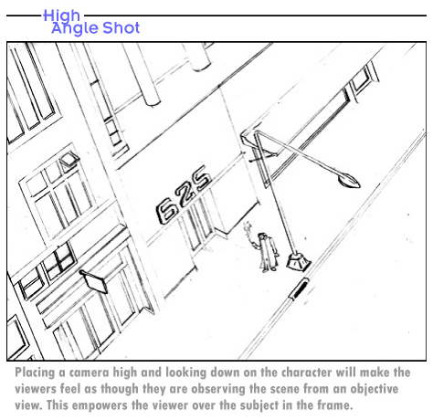
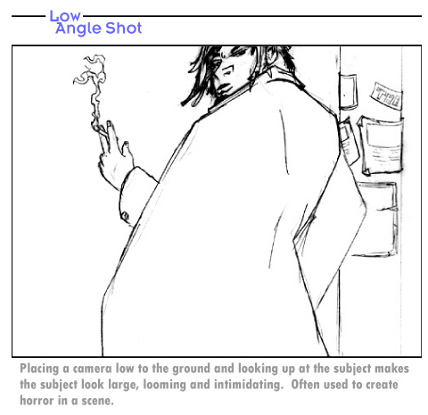
Low-Angle Shot
Now, consider placing the camera low on the ground, looking up at the subject in the frame.
What do you think is the effect on the scene?
Placing the camera low on the ground, looking up at the subject, makes the subject look large, looming, and intimidating. Low-angle shots are usually executed in combination with a wide-angle lens so the subject completely fills the frame. You can use this technique effectively to create horror scenes.
Like high-angle or aerial shots, low-angle shots are rarely experienced in real life, but the emotional effect of a low-angle shot is opposite that of the high-angle shot. While a high-angle shot places the viewer in a position of power, the low-angle shot takes all the power away from the viewer.
Cuts from high angle to low angle or vice versa are usually awkward, because the rapid transfer of power between viewer and subject creates confusion and distraction in an audience. Remember to manage such cuts well and only use them when necessary.

While vertical angles, such as high and low camera placements, address the issue of power transfer between the viewer and subject, eye-level angles depict the neutral scenes and they are generally used to build up rapport between the viewer and subject.
Eye-Level Shot
Eye-level shots create the feeling that the subject and the viewer are on equal footing in their power struggle. The two face off without one dominating the other—this angle is comfortable and it is often used in low-tension situations.
When a subject is shown in a straight-on view looking right into the camera lens, it represents a situation where viewers feel invited into the subject's personal space. On the other hand, a shot in which the subject is looking off in another direction is commonly referred to as a ¾ perspective. The viewer finds it difficult to empathize with the subject who doesn't look the viewer in the eye. This subtle camera angle can give your viewers a clue about whom they should trust and whom not to trust in the context of the story.
Straight Shot vs. ¾ Perspective
Visualize a straight, but low-angle shot—the subject will look powerful, but friendly. Now consider moving the camera to the left or right, still keeping the low angle. Suddenly, the subject becomes overbearing, imposing, and, in some cases, menacing. Both shots are low-angle, but moving from a straight-on to a ¾-perspective effectively changes the relationship between the viewer and the subject. The relationship shifts from a familiar interaction to one that is distant and cold.
Camera Placement in Games
We talked earlier about the player’s control of the camera and the differences it means for the CG camera in a game as opposed to a camera in film or animation. When we talk about camera placement in games, we have to take this control into account once more. It is no longer a director placing a camera in a corner of the room; everything you, as a player, do is seen through this one unique camera angle. The closest games come to this kind of directorial control appears in games like Burnout, where there is a choice of three camera placements as you race your car around different world cities. There is an eye-level view, a bumper view, and a high-angle view. However, in more complex games like role-playing games or first-person shooters, camera angles and perspectives are tied directly to the scene design and character movement through the environment
Camera angles and perspectives are still incorporated in every game out there. That’s how we get those fantastic moments of “Wow, look at that boss! It’s huge!” without a cinematic cut scene for every other shot. These angles are just created using different methods. For example, for a game developer to establish a low-angle shot in which an enemy towers over your hero, the developer must make the enemy a certain size and force the player to look up at his foe. A couple of great examples of this are Metroid Prime and Shadows of the Colossus. In both games, the player often encounters enemies that are of gargantuan proportions and the player must angle the camera upward to deal a blow to his enemy or to simply track his movements (as is the case in Shadows of the Colossus).

Shot Comparisons:
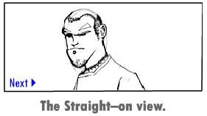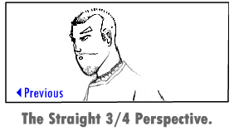

The Moving Camera
Up to this point, the discussion addressed the static or still camera in detail. Though the still image is powerful on its own, the depth of a film or animation narrative comes from the moving camera. Drama comes with a shift of "value" during a scene. For instance, when a wife comes home to a cheating husband, she transforms from a loyal partner to an embittered victim of betrayal. When a child witnesses the first moment of his or her parent's fatal weakness, he or she changes from a trusting dependent to a disappointed observer. These changes in value are what make camera scenes powerful in the eyes of a viewer. You can use a moving camera to add drama to a scene in a film or animation.
A camera moves from one point to another. The critical questions are, "Where does the movement start?" and "Where does it end?"
For example, a camera begins in a location that places the viewer in a position of power, such as a high ¾ angle. When the camera slowly drops down to a place where the viewer is in the position of weakness, a value change occurs. A distinct change occurs in the relationship between the viewer and the subject. This value change creates the drama in exactly the same way as in the case that we discussed earlier: a woman comes home to find that her husband is cheating on her.

The power of the moving camera

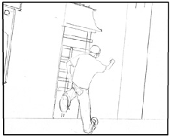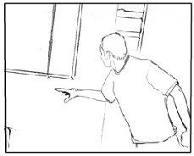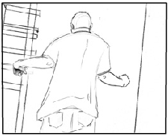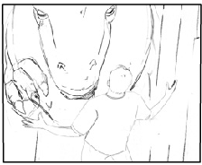

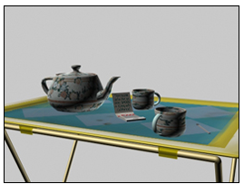
The Lights
As you learned in the previous lectures, with your camera skills in place, you have an immense potential to transform a simple scene into an interesting and involving sequence. However, can your camera skills alone transform your lackluster scene into art? To create a lively scene, you must add lights to your scene.
Lights are an integral part of the art of movie making and game development. They play an important role in the interpretation of our scenes. Week 1 lectures familiarized you with some basic elements of lighting that can be used to create different effects in a scene. Directors and developers often use these elements of light to help their viewers relate with the scene and add meaning and emotions to the scenes.
To understand how you can add basic lights to bring life to your scenes, let's begin by creating a primitive shape in your three-dimensional (3D) software.
Three-Point Lighting
Create a simple scene of a teapot kept on a table. Once your scene is created, your software automatically adds light that strikes the teapot from the direction of the camera. This default light is added to make the teapot visible, but hardly adds any value to the object's aesthetic illumination. In most 3D software, the default light disappears once other lights are added to the scene.
The three basic lights that you can add in your scene to illuminate the object are:
- Key lights
- Fill lights
- Back lights
Let's understand these three basic lights and explore how to use three-point lighting to make a difference in scenes.

Key Light
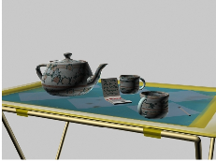
Key light is the single bright light that illuminates a subject in the scene. The key light provides the primary light value in the scene. It is usually placed in front of the subject and at an angle of 40–45 degrees to the direction of the camera to facilitate the frontal illumination of the subject.
As you add the key light to the scene, notice that the sides of the teapot appear extremely dark. Light rays are highly reflective in nature. In real life, light rays are bounced back in space upon striking the surface of an object. However, in the above scene, the absence of bounced lights from the teapot results in an unrealistic and boring scene.
Fill Light
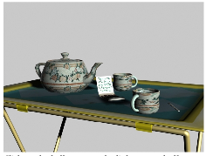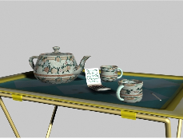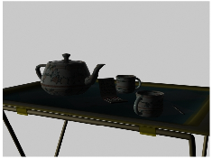
Fill light is a source of light that imitates the reflected light from an object in real life. Fill lights illuminate the background and sides of a subject. These lights are usually less bright than the key lights. The fill lights appear to bounce back from the ground toward the object.
Fill lights essentially fill up the darkness, the intensity, and solitary nature that the key lights create that softens the shadows and adds value to the dark sides of the object.
Key lights and fill lights emphasize the subject and bring three dimensionality to the scene.
Once you add the fill lights to the scene, look at the comprehensive picture of the created image. Did the dark background of the scene eat up the silhouette of the teapot?

Back Light
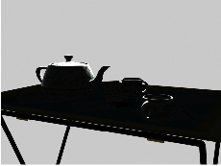
Back light is the source of light that you place behind an object to create a slim highlight that travels through the outer edges, thereby creating a silhouette of the object. Backlights can be of any color, but must have high intensity to bring out the shape of the object. Backlights are also called rim lights.
You have now created three-point lighting in your scene. A more complex light and color setup is usually built on this three-point setup of a scene.

Summary
This week, you learned the techniques to empower your viewer and the characters in a scene by specific placement and movement of the camera. You’ve begun to grasp the differences between in-game cameras and cameras for animation and film. You also learned about the basic three-point lighting that illuminates a scene. A director enhances a scene and game play with these techniques.
While these techniques can bring out the intent of a scene, their indiscriminate use may disturb the viewers' equilibrium, leaving them struggling to understand their relationship with the camera and scene. With balanced camera movements, you should also use lighting with care and insight. Whether your intent is to confuse the audience or to guide them seamlessly through the experience, convey what your scenes intend. Don't add an unnecessary light or move the camera in a way that would not add any value.
Assignment 1: Discussion Questions
By Friday, May 21, 2010, go to the Discussion Area and post responses to two of the discussion questions assigned by the facilitator. All responses should be posted to this Discussion Area.
Before the end of the week, begin commenting on at least two of your peers' responses. You can ask technical questions or respond generally to the overall experience. Be objective, clear, and concise. Always use constructive language, even in criticism, to work toward the goal of positive progress. Submit your responses to the appropriate topic in this Discussion Area.
Assignment 1 Grading Criteria | Maximum Points
Response Criteria
Met the criteria for the correct responses to the questions assigned. | 4
Used vocabulary relevant to the current week's topics—at least four terms. | 4
Participation Criteria
Used vocabulary relevant to the current week's topics—at least four terms. | 4
Participated in the discussion by asking a question, providing a statement of clarification, providing a point of view with rationale, challenging a point of discussion, or making a relationship between one or more points of the discussion. | 4
Justified ideas and responses by using appropriate examples and references from texts, Web sites, and other references or personal experience. | 4
Total: | 20
For assistance with any problems you may have when completing this assignment—OR—to offer your assistance to classmates, please use theProblems and Solutions Discussion area located through the left side navigation link.

DQ 1 – Dramatic Effect
Pick a scene that you created in one of your previous courses. With your knowledge of camera placement and movement, discuss how you can improve on the scene to convey the desired emotional or dramatic effect. Be specific on camera angles and positions in relation to scenes within your project. Post your original file here to the Discussion Area with your comments.

DQ 2 – In game vs cut scene camera
Explain how each camera differs in how they elicit the same kind of angles and perspectives.

DQ 3 – Games vs films
Thinking about the camera control given to the player in game, comment on how the camera is a window to view the story world. How does this differ from films? Express your opinion.

DQ 4 – Technology vs art
Which facet of animation is more important in your opinion—art or technology? Support your answer with valid reasons.

DQ 5 – Long lens vs wide lens
Based on your knowledge of perspective drawing from the previous classes, explain how you set up a drawing in perspective that simulates a long lens vs. a wide lens. How important is it for a storyboard artist to know the lens focal length when dealing with computer graphics (CG) filmmakers?

Assignment 2: Camera Placement and Emotional Impact
Using the techniques from this week's lectures, create a simple animation of a ball bouncing across a plane. Render the scene at 320 x 240 resolution, and employ three cuts to convey at least three different moods for this scene by using different lighting effects and camera placement to add to the emotional impact. You can convey the following moods in your scenes:
- Anger
- Loneliness
- Fear
Note: Limit the background elements to cylinders to show movement through the environment.
Save your animation files as: Sequence_number_First name. For example: Sequence_1_John.mov, Sequence_2_John.mov.
Submit your assignment as a ZIP file.
By Sunday, May 23, 2010, post the rendered scenes to the W2: Assignment 2 Doc Sharing folder and your observations to this Discussion Area. Review and critique the work of at least two other students as early as possible and comment on the way they have used various effects to convey depth and mood. Then, revise your work based on the peer reviews you have received and after incorporating the changes post it to the W2: Assignment 2 Doc Sharing folder by the end of the week.
Assignment 2 Grading Criteria | Maximum Points
Created three animations conveying three different moods. (3 x 6 points for each scene) | 18
Effectively conveyed three different emotions in each rendered scene. (3 x 6 points for each emotion) | 18
Displayed an understanding of the use of camera and lighting to depict emotions. | 8
Actively participated in the Discussion Area. | 4
Total: | 48
For assistance with any problems you may have when completing this assignment—OR—to offer your assistance to classmates, please use theProblems and Solutions Discussion area located through the left side navigation link.
Pro Tip:
Please post your files here to the DISCUSSION BOARD

Assignment 3: Final Project: Scene Planning—Phase I
Choose a scene that you created in one of your previous courses. Create a simple description of the emotional intent of this scene. Based on this written emotional intent, create a professional storyboard to build a new rendering schematic. Focus on each panel. Describe the shot, placement and movement of camera, and the light setup in this scene.
Save your storyboard panel following this sample naming convention: Storyboard_First name. Render at 640 x 480 ppi.
Post your storyboard and responses to this Discussion Area by Tuesday, May 25, 2010. Review and critique the work of at least two other students as early as possible and provide suggestions for improvement. Then, revise your work based on the peer reviews that you receive. By the end of the week, post it and invite the reviewers to comment on your changes.
Note: In the following weeks, you will modify this scene in several ways. You must also use one or more variations of the scene for your final project to be submitted inWeeks 5 and 6.
Assignment 3 Grading Criteria | Maximum Points
Prepared a panel-by-panel storyboard proposal for the chosen scene. | 8
Illustrated the scale of shot, angel of shot, and camera placement/movement in each panel. | 12
Included numbering and the indication of perspective in the boards. | 4
Actively participated in the discussion and provided constructive comments about the responses posted by other students. | 8
Total: | 32
For assistance with any problems you may have when completing this assignment—OR—to offer your assistance to classmates, please use theProblems and Solutions Discussion area located through the left side navigation link.
Pro Tip:
Please post your files here to the DISCUSSION BOARD

